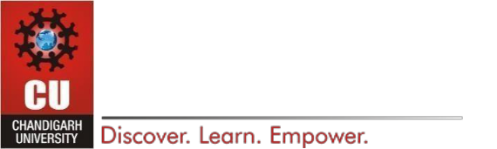
DEPARTMENT OF

COMPUTER SCIENCE & ENGINEERING

Experiment 6

Student Name: Pratik Kaushal | UID:22BCS10026
Branch: CSE | Section/Group:DL-902/A
Semester: 6 | Date of Performance:24-02-2025
Subject Name: Java with Lab | Subject Code: 22CSH-359

- Aim: Develop Java programs using lambda expressions and stream operations for sorting, filtering, and processing large datasets efficiently.

- Objective:

  - Develop Java programs using lambda expressions and stream operations for sorting, filtering, and processing large datasets efficiently.

  - Implement easy, medium, and hard-level tasks involving sorting employees, filtering and sorting students, and processing products using streams.

- Implementation/Code:

a. import java.util.*;

class Employee {

String name;

int age;

double salary;

Employee(String name, int age, double salary) {

this.name = name;

this.age = age;

this.salary = salary;

}

@Override

public String toString() {

return name + " - Age: " + age + ", Salary: " + salary;

}

}

public class EmployeeSort {

public static void main(String[] args) {

List<Employee> employees = Arrays.asList(

new Employee("Ayush", 20, 90000),

new Employee("Vinay", 22, 100000),
DEPARTMENT OF

COMPUTER SCIENCE & ENGINEERING

new Employee("Prakul", 23, 70000)

);

employees.sort(Comparator.comparing(emp -> emp.name));

System.out.println("Sorted by Name: " + employees);

employees.sort(Comparator.comparingInt(emp -> emp.age));

System.out.println("Sorted by Age: " + employees);

employees.sort(Comparator.comparingDouble(emp -> emp.salary));

System.out.println("Sorted by Salary: " + employees);

}

}

b. import java.util.*;

import java.util.stream.Collectors;

class Student {

private String name;

private double marks;

public Student(String name, double marks) {

this.name = name;

this.marks = marks;

}

public String getName() {

return name;

}

public double getMarks() {

return marks;

}

}

public class StudentFilter {

public static void main(String[] args) {

List<Student> students = List.of(

new Student("Ayush", 85),

new Student("Rajeev", 70),

new Student("Vinay", 90),

new Student("David", 60),

new Student("Prakul", 80)

);
DEPARTMENT OF

COMPUTER SCIENCE & ENGINEERING

List<String> topStudents = students.stream()

.filter(s -> s.getMarks() > 75)

.sorted(Comparator.comparingDouble(Student::getMarks).reversed())

.map(Student::getName)

.collect(Collectors.toList()); System.out.println("Top Students: " + topStudents);

}

}

c. import java.util.*;

import java.util.stream.Collectors;

class Product {

String name;

String category;

double price;

public Product(String name, String category, double price) { this.name = name;

this.category = category;

this.price = price;

}

@Override

public String toString() {

return name + " ($" + price + ")";

}

}

public class ProductProcessor {

public static void main(String[] args) {

List<Product> products = Arrays.asList(

new Product("Laptop", "Electronics", 1200),

new Product("Phone", "Electronics", 800),

new Product("TV", "Electronics", 1500),

new Product("Shirt", "Clothing", 50),

new Product("Jeans", "Clothing", 70),

new Product("Blender", "Appliances", 200),

new Product("Toaster", "Appliances", 100)

);
DEPARTMENT OF

COMPUTER SCIENCE & ENGINEERING

Map<String, List<Product>> productsByCategory = products.stream()

.collect(Collectors.groupingBy(p -> p.category)); System.out.println("Products grouped by category:"); productsByCategory.forEach((category, productList) ->

System.out.println(category + ": " + productList));

Map<String, Optional<Product>> mostExpensiveByCategory = products.stream()

.collect(Collectors.groupingBy(

p -> p.category,

Collectors.maxBy(Comparator.comparingDouble(p -> p.price))

));

System.out.println("\nMost expensive product in each category:"); mostExpensiveByCategory.forEach((category, product) ->
System.out.println(category + ": " + product.orElse(null))); double averagePrice = products.stream()
.mapToDouble(p -> p.price)

.average()

.orElse(0);

System.out.println("\nAverage price of all products: $" + averagePrice);

}

}

- Output:
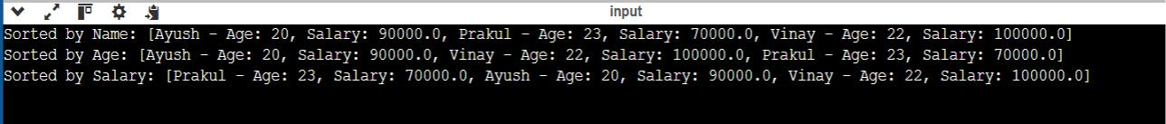
DEPARTMENT OF

COMPUTER SCIENCE & ENGINEERING
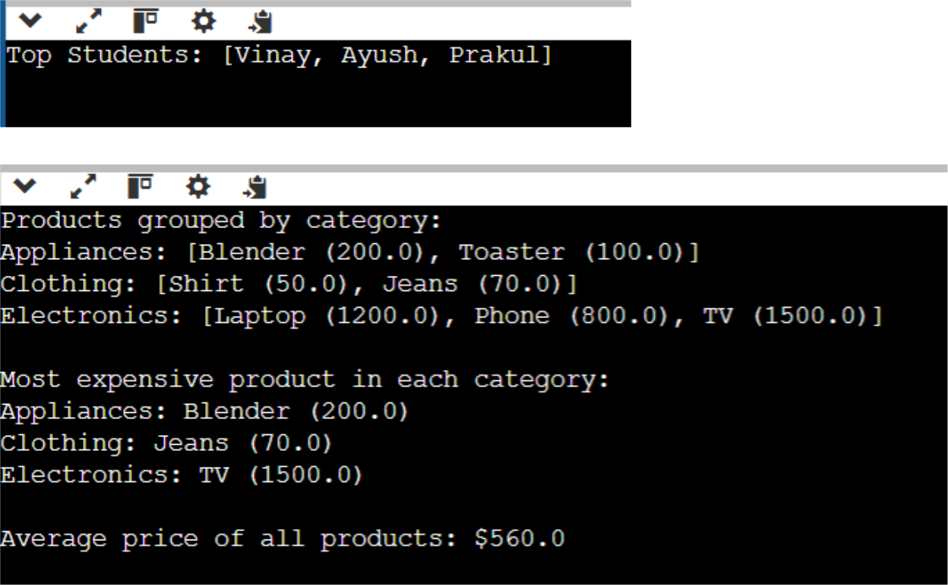

- Learning Outcome:

  - Understand and implement lambda expressions for sorting objects in a list based on different attributes.

  - Utilize Java Streams API to perform operations like filtering, sorting, and mapping efficiently on large datasets.
  - Learn Comparator and method references to simplify object comparisons for sorting.

  - Apply grouping and aggregation functions using Collectors.groupingBy() and Collectors.maxBy() for processing categorized data.

  - Gain hands-on experience in computing statistical values like the average from a dataset using mapToDouble() and average().

  - Improve code efficiency and readability by using functional programming techniques in Java.

